__________________________ Name

Chernobyl Group Activities

Instructions: With your group, complete each activity.

Activity 1: News Report

Video 1 (Watch until the five minute mark)

    - What did Moscow news stations claim?

    - What did they show to support their claim?

    - What are some of the symptoms that workers exposed to high amounts of radiation might suffer?

    - Were experts concerned about radioactive fallout reaching the US?

    - If the Ukrainian grain were damaged by the accident, what would Russia have to do?

Video 2
    - What did the Soviets claim happened at the Chernobyl Atomic Plant to one of the atomic reactors?
    - Why were the Soviets quick to acknowledge the “accident”?
    - What happened to the “radioactive cloud” that originated near Kiev?
    - How many nuclear reactors did the Soviet Union have?
    - Why was the radiation not contained?
Question:
Justify the Soviet Union officials’ decision to withhold information from the international community about the damage done to Chernobyl.
_________________________________________________________________________________________________________________________________
___________________________________________________________________________________________________________________________________________________________________________________________________________________________________________________________________________________________________________________________________________________________________________________________________
_________________________________________________________________________________________________________________________________
Activity 2: Timeline
Try to piece together the timeline of Chernobyl from first to last. Show your answer by writing the order you think the events go in.
First : ___________ ___________
___________ ___________
___________ ___________
___________ ___________
___________ ___________
___________ ___________ :Last
___________
Activity 3: Picture Analysis
In your group, pair off. One group will analyze Photo 1, while the other will analyze Photo 2. Once you are done, collaborate with your group and compare pictures.

Photo 1
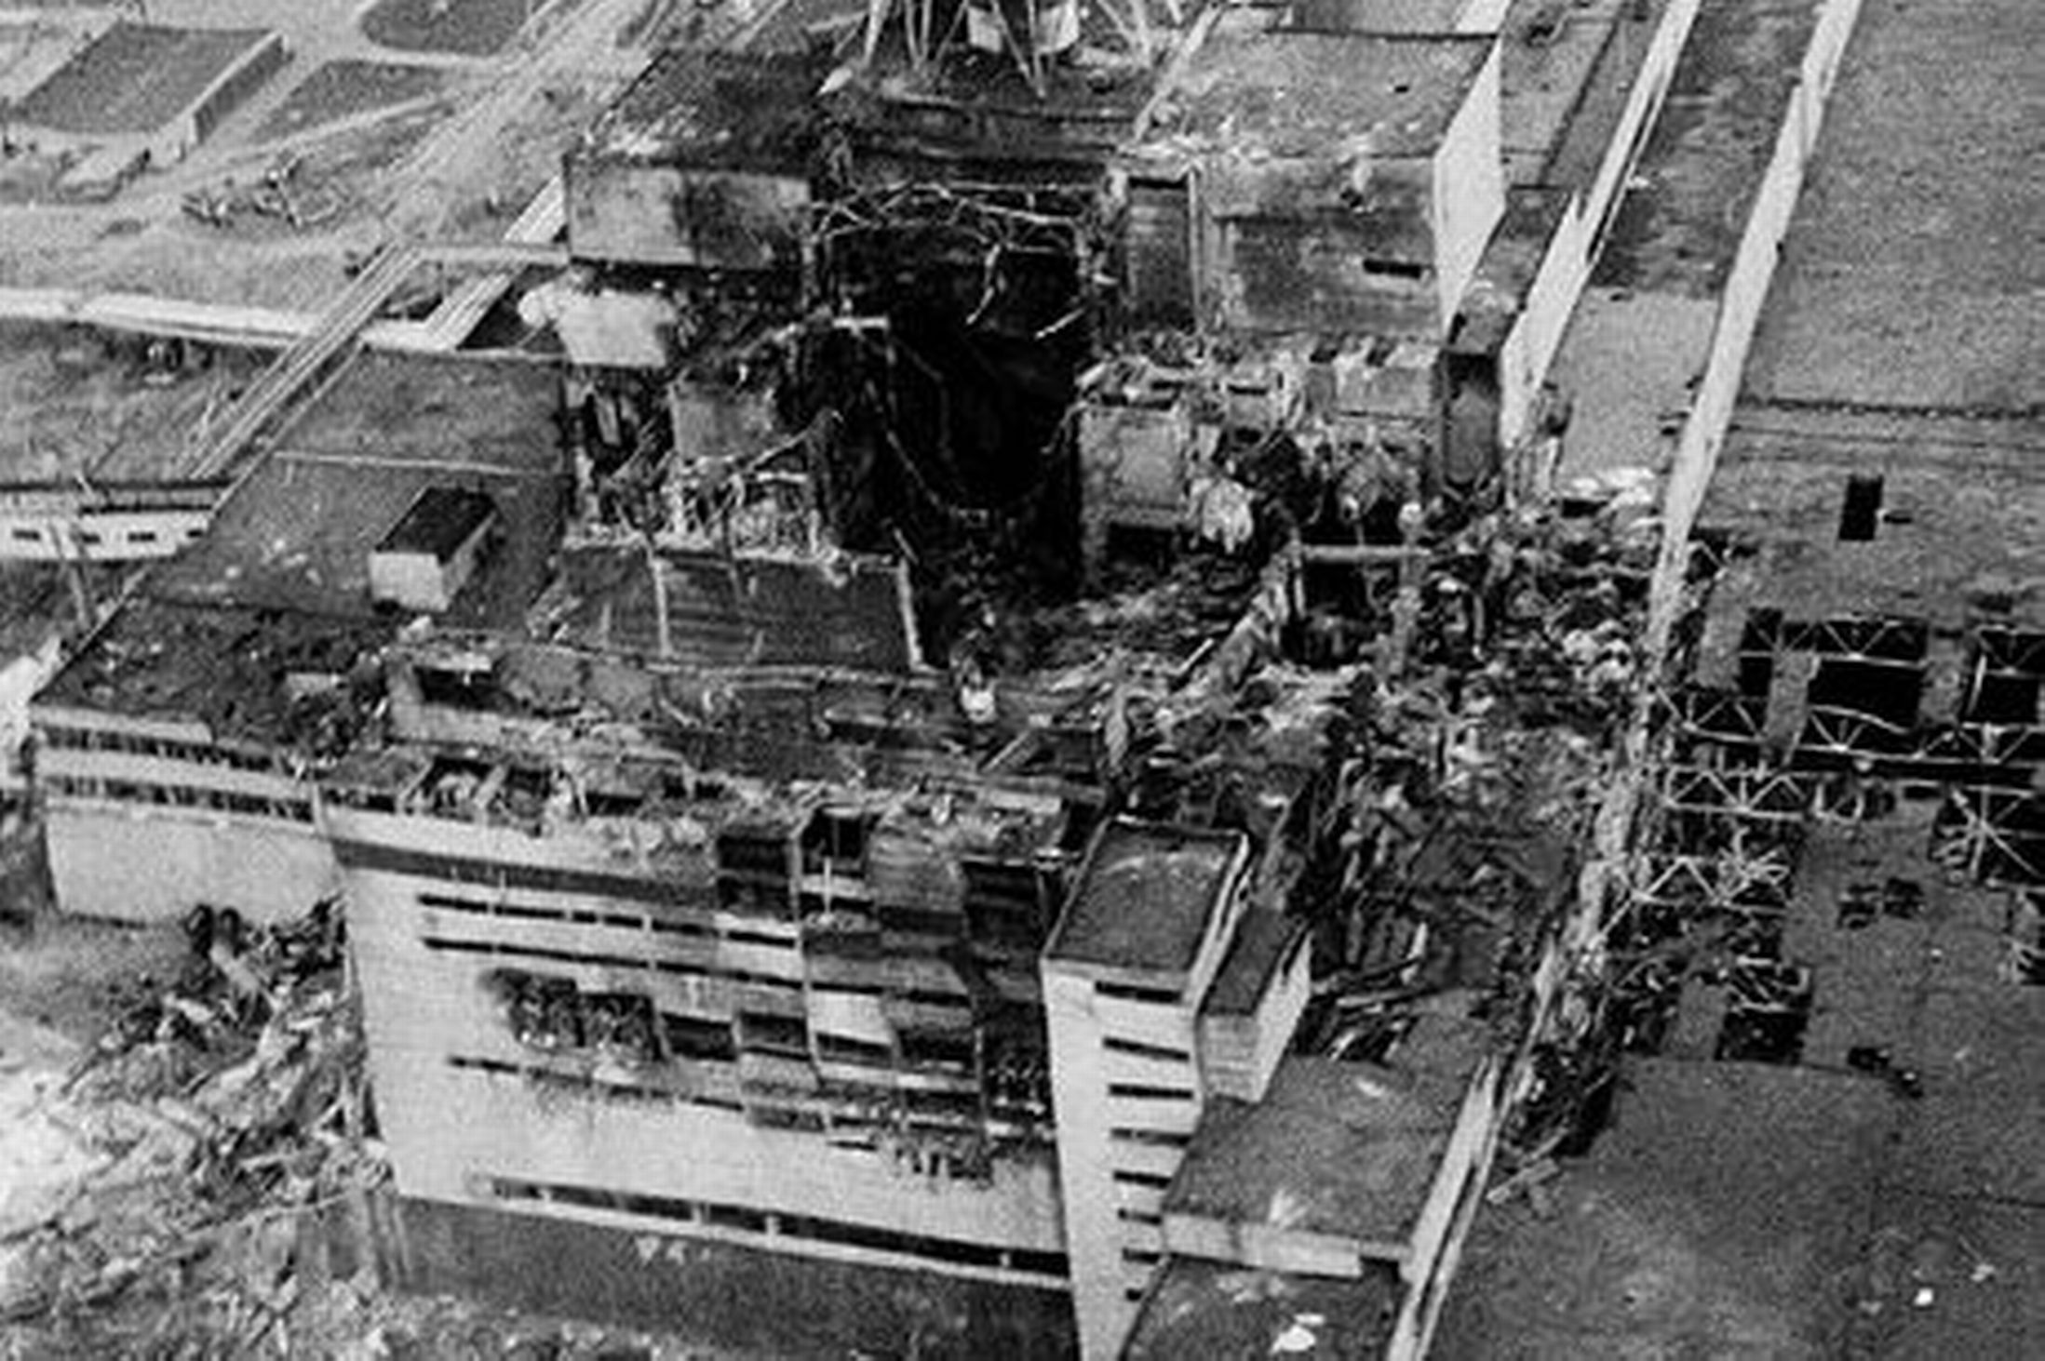

Analysis

- Describe what you see:

- Infer what happened:

- Evaluate the situation:

Photo 2)
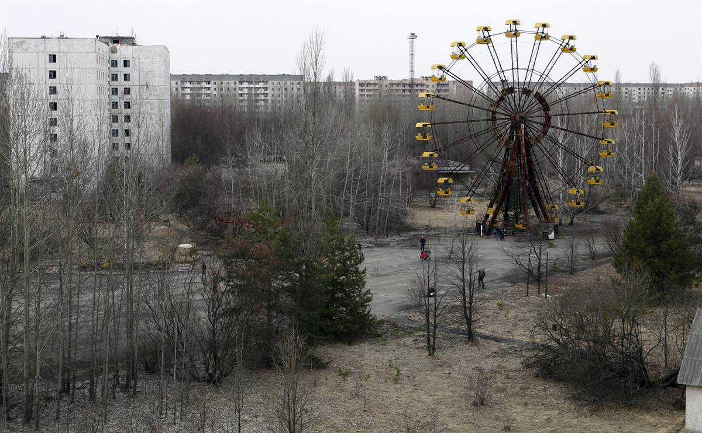

Analysis

- Describe what you see:

- Infer what happened:

- Evaluate the situation:

Group Question: What are the global consequences of the accident at Chernobyl?

Activity 4:
Define the following terms.

Regional Cooperation:

Transboundary Pollution:

Why would countries in Europe (and around the world) be concerned about nuclear fallout from the Chernobyl Accident?

__________________________________________________________________________________________________________________________________________________________________________________________________________________________________________________________________
_________________________________________________________________________________________________________________________________

How could Soviet Russia cooperated differently with its neighbors?

__________________________________________________________________________________________________________________________________________________________________________________________________________________________________________________________________
_________________________________________________________________________________________________________________________________

Activity 5:
Re-watch Gummy Bear Chernobyl

- If you were a citizen of the Soviet Union, what would you have wanted to know from the government?

_________________________________________________________________________________________________________________________________
___________________________________________________________________________________________________________________________________________________________________________________________________________________________________________________________________________________________________________________________________________________________________________________________________
_________________________________________________________________________________________________________________________________

