Name:_______________________

Cold War Europe

Introduction

The Cold War was a long period of tension between the democracies of the Western World and the communist countries of Eastern Europe. The west was led by the United States and Eastern Europe was led by the Soviet Union. These two countries became known as superpowers.

Proxy Wars Although the two superpowers never officially declared war on each other, they fought indirectly in proxy wars, the arms race, and the space race. Time Period (1945 - 1991) The Cold War began not too long after World War II ended in 1945. Although, the Soviet Union was an important member of the Allied Powers, there was great distrust between the Soviet Union and the rest of the Allies. The Allies were concerned with the brutal leadership of Joseph Stalin as well as the spread of communism. The Cold War came to an end with the collapse of the Soviet Union in 1991. Proxy Wars The Cold War was often fought between the superpowers of the United States and the Soviet Union in something called a proxy war. These were wars fought between other countries, but with each side getting support from a different superpower. Examples of proxy wars include the Korean War, the Vietnam War, the Yom Kippur War, and the Soviet Afghanistan War.

Arms Race and Space Race The United States and the Soviet Union also tried to fight the Cold War by demonstrating their power and technology. One example of this was the Arms Race where each side tried to have the best weapons and the most nuclear bombs. The idea was that a large stockpile of weapons would deter the other side from ever attacking. Another example was the Space Race, where each side tried to show that it had the better scientists and technology by accomplishing certain space missions first. Read more at: http://www.ducksters.com/history/cold_war/summary.php

Questions:
- Who were the major superpowers at the end of WWII?

- What is a proxy war?

What is a “cold war”?

Hot War : actual warfare. All talks have failed and the armies are fighting.

Warm War : talks are still going on and there would always be a chance of a peaceful outcome but armies, navies etc. are being fully mobilised and war plans are being put into operation ready for the command to fight.

Cold War : term is used to describe the relationship between America and the Soviet Union 1945 to 1980. Neither side ever fought the other – the consequences would be too appalling – but they did ‘fight’ for their beliefs using client states who fought for their beliefs on their behalf e.g. South Vietnam was anticommunist and was supplied by America during the war while North Vietnam was pro-Communist and fought the south (and the Americans) using weapons from communist Russia or communist China. In Afghanistan, the Americans supplied the rebel Afghans after the Soviet Union invaded in 1979 while they never physically involved themselves thus avoiding a direct clash with the Soviet Union.

Questions:
- Why was the Cold War referred to as “cold”?

- Why do communist and democratic countries conflict with each other (think back to the spectrum of economies/who is in control)?

- What is a hot war?

- Provide some examples of “client states.”

Arms Race: During the Cold War the United States and the Soviet Union became engaged in a nuclear arms race. They both spent billions and billions of dollars trying to build up huge stockpiles of nuclear weapons. Near the end of the Cold War the Soviet Union was spending around 27% of its total gross national product on the military. This was crippling to their economy and helped to bring an end to the Cold War.

Mutual Assured Destruction: One of the major factors in the Cold War was termed Mutual Assured Destruction or MAD. This meant that both countries could destroy the other country in the case of attack. It wouldn't matter how successful the first strike was, the other side could still retaliate and destroy the country which first attacked. For this reason, neither side ever used nuclear weapons. The cost was too high. Read more at: http://www.ducksters.com/history/cold_war/arms_race.phpThis text is Copyright © Ducksters.

Questions:

- How did the arms race affect the USSR’s economy?

- Predict why the Cold War never turned “hot.” (Refer to Mutual Assured Destruction)

Truman Doctrine

On Friday, February 21, 1947, the British Embassy informed the U.S. State Department officials that Great Britain could no longer provide financial aid to the governments of Greece and Turkey. American policymakers had been monitoring Greece's crumbling economic and political conditions, especially the rise of the Communist-led insurgency known as the National Liberation Front, or the EAM/ELAS. The United States had also been following events in Turkey, where a weak government faced Soviet pressure to share control of the strategic Dardanelle Straits. When Britain announced that it would withdraw aid to Greece and Turkey, the responsibility was passed on to the United States.

“It must be the policy of the United States to support free peoples who are resisting attempted subjugation by armed minorities or by outside pressures." Harry Truman

Question:
- When Harry Truman, an American president, references “outside pressures” what country do you think he is alluding (hinting) to?

NATO

In 1949, the prospect of further Communist expansion prompted the United States and 11 other Western nations to form the North Atlantic Treaty Organization (NATO). The Soviet Union and its affiliated Communist nations in Eastern Europe founded a rival alliance, the Warsaw Pact, in 1955. The alignment of nearly every European nation into one of the two opposing camps formalized the political division of the European continent that had taken place since World War II (1939-45). This alignment provided the framework for the military standoff that continued throughout the Cold War (1945-91).

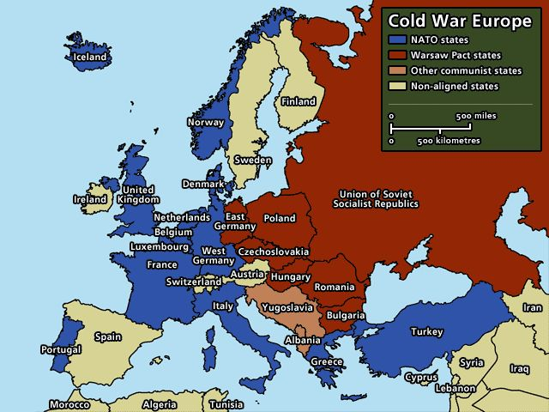

List 7 Countries that were in NATO.
1) ____________________________________________ 5) ____________________________________________
2) ____________________________________________ 6) ____________________________________________
3) ____________________________________________ 7) ____________________________________________
4) ____________________________________________
List 5 countries under Soviet control.
1) ____________________________________________ 4) ____________________________________________
2) ____________________________________________ 5) ____________________________________________
3) ____________________________________________

What was the purpose of NATO?

Dissolution of USSR

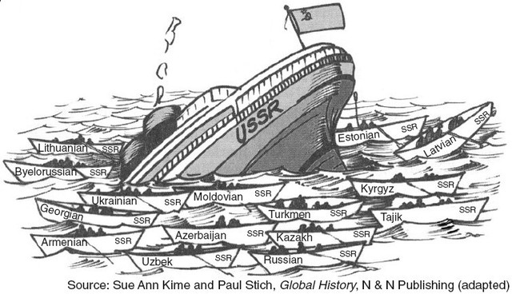
On Christmas Day 1991, the Soviet flag flew over the Kremlin in Moscow for the last time. A few days earlier, representatives from 11 Soviet republics (Ukraine, the Russian Federation, Belarus, Armenia, Azerbaijan, Kazakhstan, Kyrgyzstan, Moldova, Turkmenistan, Tajikistan and Uzbekistan) met in the Kazakh city of Alma-Ata and announced that they would no longer be part of the Soviet Union. Instead, they declared they would establish a Commonwealth of Independent States. Because the three Baltic republics (Latvia, Lithuania and Estonia) had already declared their independence from the USSR, only one of its 15 republics, Georgia, remained. The once-mighty Soviet Union had fallen, largely due to the great number of radical reforms that Soviet president Mikhail Gorbachev had implemented during his six years as the leader of the USSR. However, Gorbachev was disappointed in the dissolution of his nation and resigned from his job on December 25. It was a peaceful end to a long, terrifying and sometimes bloody epoch in world history.

Questions:

- How many states declared independency from USSR in December 1991?

- How did the Cold War come to an end?

- Why was the USSR unable to sustain itself (in other words, why did it fail)?

- What does the picture depict?

HIPPO

Historical Context: What time period do you think this came from? Why?
Intended Audience: Who do you think the artist of the picture wanted to see his work?
Purpose: What is the purpose of the picture?
Point of View: What is point of view of the artist (take a guess)?
Overall goal: What is the point of the picture?

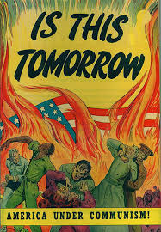
Historical Context:

Intended Audience

Purpose

Point of View

Overview/Goal:

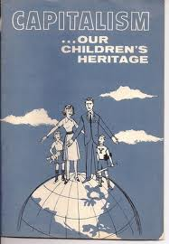
Historical Context:

Intended Audience

Purpose

Point of View

Overview/Goal:

Overall Idea: What are the lasting effects of the Cold War on Europe? 5 sentences

____________________________________________________________________________________________________________
________________________________________________________________________________________________________________________________________________________________________________________________________________________________________________________________________________________________________________________________________________________________________________________________________________________________________________________________________________________________________________________________________________________________________________________________________________________________________________________________________________________________________________________________________________________________________________________________________________________________________________________________________________________________________________________________________________________________________________________________________________________________________________________________________________________________________________________________________________________________________________________________________________________________________________________________________________________________________________________________________________

