THE ONE PAGER: Long Walk to Water

Follow this format for your One-Pager.
- Use unlined white paper.
- Title the One-Pager appropriately to reflect the content and chapter.
- Use colored pens, pencils, or markers. The more visually appealing it is, the more you will learn.
- Fill the entire page. Fill the entire page. Fill the entire page. Fill the entire page.
- Be purposeful about the arrangement of your One-Pager.
  - For example, have a reason for using a certain color or for placing an object in a certain place.
- Write two quotations from the reading.
- Use three visual images, either drawn or printed out (at home), to create a central focus to your page.
  - If you use a computer image, personalize it to make it your own.
- Place five essential vocabulary words/phrases around the images.
  - These terms/words/phrases should express the main ideas, your impressions, feelings, or thoughts about what you have seen or read.
- Write the main idea of the reading.
- Write two short answer questions and answer them.
- Write your name on the back!!! Write your name on the back!!! Write your name on the back!!!

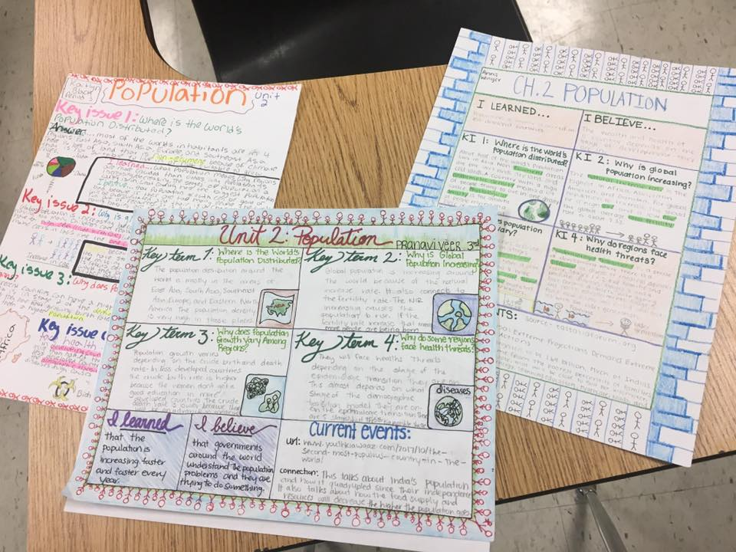
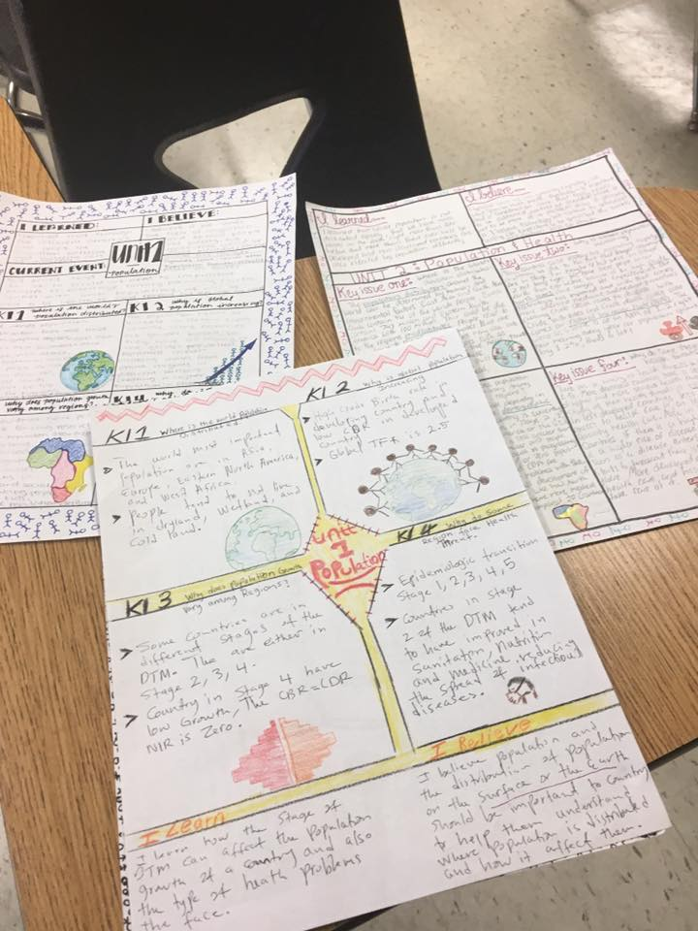

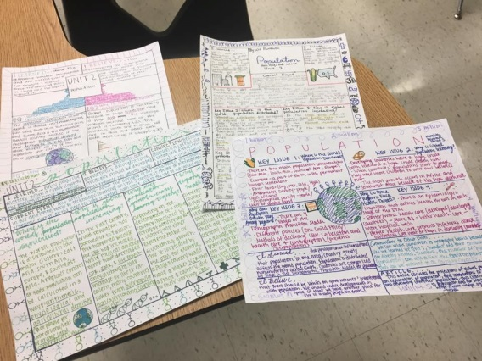

Rubric for each One Pager (Daily Assignment)

Item | 5 | 4-2 | 1-0
Content | - Key Issues from assigned chapters are represented.  - 5 essential vocab/phrases are placed around the page highlighting ideas  - Main ideas of readings are found. | - Key Issues 1-4 are represented, at least 3 are fully represented.  - 4 essential vocab/phrases are placed around the page highlighting ideas  - Main ideas of readings are found. | - Key Issues 1-4 are mentioned, 1-2 are fully defined.  - 1-3 essential vocab/phrases are placed around the page may connect with issues  - 1-3 main ideas of readings are found.
Pictures | - Includes pictures that are clearly connected with the Key Issue  - Hand drawn pictures full color  - Computer generated pictures may be used - must be personalized w/credit for picture is on back | - Includes pictures that are clearly connected with 2 of 4 Key Issues  - Hand drawn pictures 75% are in full color  - Computer generated pictures may be used - more than 50% are personalized w/credit for picture on back | - Includes pictures that are clearly connected with 1 of 4 Key Issues  - Hand drawn pictures are pencil whipped in #2 pencil.  - Computer generated pictures may be used less than 50% are personalized w/credit for picture is on back
Quotes & Questions | - 2 quotes from reading  - 2 short answer questions  - 2 answers to the questions written in 3-4 complete sentences | - 1 quotes from reading  - 1 short answer questions  - 1 answer to the question written in 1-2 complete sentences | - 0 quotes from reading  - 0 short answer questions  - 0 answers to the questions written in incomplete sentence(s)
Format | - Unlined white paper  - Full-color (colored pencil, ink pens, markers)  - Entire page is covered  - Name & Period # on back | - Unlined paper (white or colored)  - Black ink only  - ¾ of page is covered¹  - Name on back | - Lined or grid paper (white or colored)  - Black ink and #2 pencil  - ½ or less page is covered¹

While large or bold writing can be used to highlight or bring attention to an idea or section, using exaggerated writing to fill the page is not acceptable.

