Problem Solving

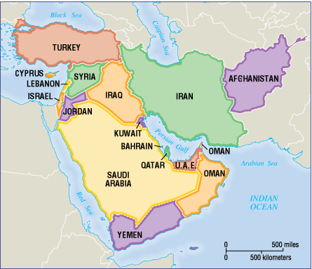

The Problem: You are the leader of Afghanistan, which has a large supply of oil; however, you are landlocked. How do you propose to get your oil from your country to Europe? Describe the route below.

What does “landlocked” mean?

__________________________________________________________________________________________________
Find someone with a different idea than yours. What does he or she suggest?

